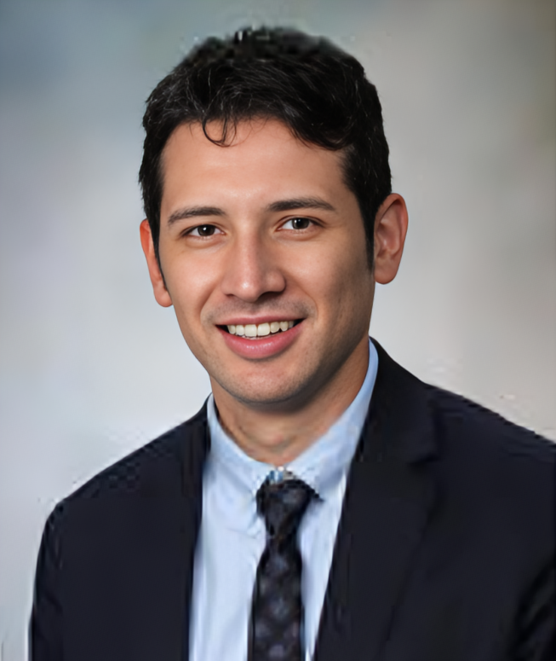

**Phillip Gonzalez, MOT, OTR, BCPR**

Critical Care Occupational Therapist

AOTA Board Certified in Physical Rehabilitation

***Clinical Specialist, VitalGo Systems***

Email: [phillip@vitalgosys.com](mailto:phillip@vitalgosys.com)

Phone: (915) 422-4835

Phillip Gonzalez is a Critical Care Occupational Therapist, Board Certified in Physical Rehabilitation by the American Occupational Therapy Association, and a graduate of Texas Tech University Health Science Center Masters in Occupational Therapy Program in 2014 and currently serves as a Clinical Specialist for VitalGo Systems.

Phillip prides himself on pushing the boundaries of what OT’s role is in critical care rehabilitation and since the start of his career in 2015, has served as Primary Occupational Therapist in multiple multi-specialty intensive care units (ICUs) at various hospitals. Most notably, Phillip highlights his time working at Baylor Scott and White Regional Medical Center in Grapevine, Texas, University Hospital in San Antonio Texas, and Mayo Clinic in Jacksonville, Florida as cornerstones in developing his passion for ICU rehabilitation.

Phillip's expertise is in working with poly-traumatic injuries, spinal cord and traumatic brain injuries, pre/post heart and lung transplants, and patients on ECMO and other forms of mechanical circulatory support. Prior to working for VitalGo Systems, Phillip would integrate the Total Lift Bed into his plan of care for patients in the ICU to enhance a patient's participation in OT intervention plans with respect to the acuity and complexity of their condition.

As an advocate for the continued expansion of OTs foundational knowledge in critical care medicine, he empowers others to be better advocates for their profession, their patients, and their careers. He has delivered guest lectures at Occupational Therapy Assistant and Doctor of Occupational Therapy programs, presented at state and national conferences, produced educational lectures for healthcare institutions in the United States and Latin America, freelances as a critical care consultant, and recently published an article on strategies to create an Awake and Walking ICU. Phillip is an active member of the Society of Critical Care Medicine Texas Chapter, American Occupational Therapy Association, and Texas Occupational Therapy Association, and continues to provide patient care as a PRN OT at University Hospital.